MARKER’S REPORT

Name of Marker : Munish Kumar

Course Code/Title : ANL252

Semester : Jul 2021

PART I

Overall Performance of Students in the Examination:

Briefly Describe:

Majority of students passed. Passing rate of 97%. Of 33 students graded, the only failure was due to an incomplete paper.Shown below is the Mean grade of 66.03%.

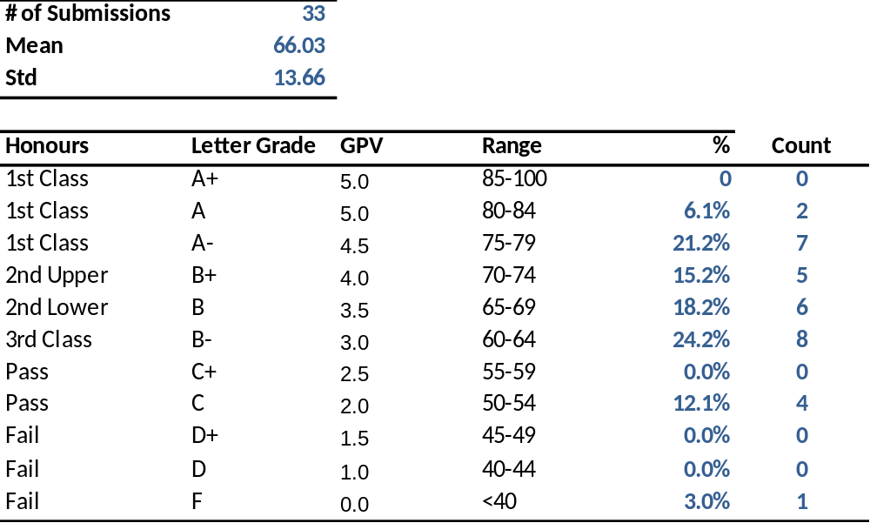

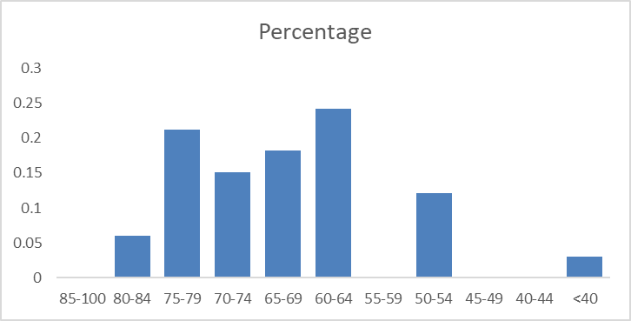

Strengths and Weaknesses of Students in Examination:

Students can be broadly categorized into 2 groups. For students that generally understood the programming goals and methods, their shortcoming was in the explanation of theory and the length of their codes (One of my students submitted 40 pages of code, because they painstakingly wrote out each one instead of using a loop – however, his code was a working code ). For students who had a strong grasp of the theory, they were creative in the programming choices and wrote very elegant, efficient codes.

However, nearly every student struggled with descriptive questions related to explaining theory or explaining how algorithms and things worked within python.

PART II

Overall performance of Question 1a to 1d, 2a to c.

Please see the Bloom Learning outcomes score below

S/N | Learning Outcomes | Bloom’s Level | Question Number | Mean Score | Pass Rate
1 | Differentiate the various aspects  of Python programming.
2 | Discuss how Python manages  packages, modules, functions, etc. | 2 | 2a | 5.4 | 53.6
3 | Explain the operations on arrays  and datasets. | 2 | 1c | 2.8 | 34.5
4 | Design Python programmes for  performing data analytics. | 5 | 1a | 24.7 | 74.9
5 | Employ logic control flows in  Python programmes. | 3 | 2c | 5.4 | 53.9
6 | Prepare data for analysis using  Python programming. | 5 | 1 | 48.9 | 69.9
7 | Analyse data using appropriate  tools and techniques with Python  programming. | 4 | 2b | 6.3 | 63.3

Strengths and weaknesses of students with regard to Question
1a to 1d, 2a to c.

Most students did reasonably well when it came to showing their skills with python, refer to statistics below

 | 1a | 1b | 1c | 1d | 2a | 2b | 2c
Mean | 24.7 | 11.4 | 2.8 | 10.1 | 5.36 | 6.33 | 5.39
Standard Error | 0.8 | 0.4 | 0.2 | 0.5 | 0.45 | 0.40 | 0.52
Median | 26.0 | 12.0 | 3.0 | 10.0 | 6.00 | 7.00 | 6.00
Mode | 28.0 | 11.0 | 3.0 | 9.0 | 4.00 | 7.00 | 8.00
Standard Deviation | 4.7 | 2.6 | 1.2 | 2.7 | 2.58 | 2.30 | 2.97
Sample Variance | 22.5 | 6.6 | 1.4 | 7.4 | 6.68 | 5.29 | 8.81
Kurtosis | 3.7 | 11.6 | 0.1 | 5.5 | 0.46 | 1.99 | -0.62
Skewness | -1.7 | -2.8 | -0.5 | -1.6 | -0.02 | -1.37 | -0.85
Range | 22.0 | 14.0 | 5.0 | 14.0 | 12.00 | 10.00 | 9.00
Minimum | 8.0 | 0.0 | 0.0 | 0.0 | 0.00 | 0.00 | 0.00
Maximum | 30.0 | 14.0 | 5.0 | 14.0 | 12.00 | 10.00 | 9.00
Sum | 816.0 | 376.0 | 91.0 | 332.0 | 177.00 | 209.00 | 178.00
Count | 33.0 | 33.0 | 33.0 | 33.0 | 33.00 | 33.00 | 33.00
Confidence Level(95.0%) | 1.7 | 0.9 | 0.4 | 1.0 | 0.92 | 0.82 | 1.05

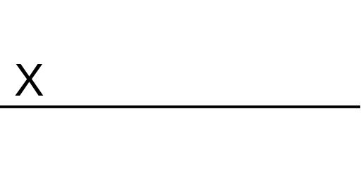 |  | Sept 2021
Marker’s Signature |  | Date

